Below line chart helps us to get information about the growth and fall during given fiscal quarter at the three different locations.

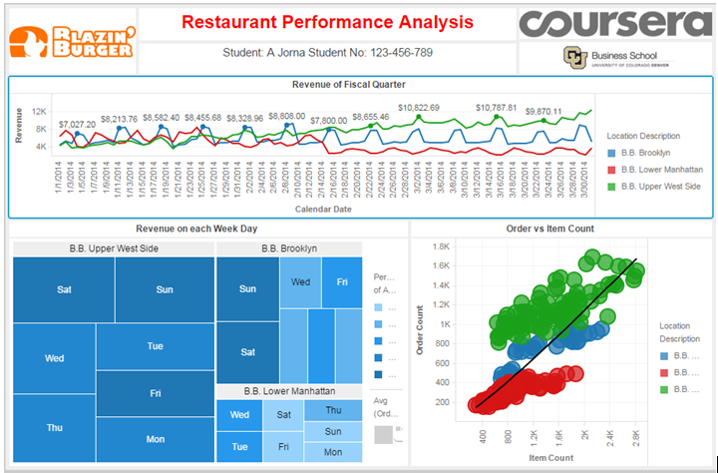

Below analysis helps us to analyze performance with the help of the Health Inspection Score

